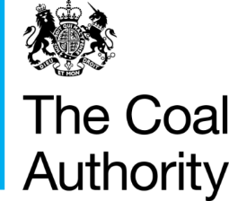

Resolving the impacts of mining

A geochemical comparison of the coal mine waters of Great Britain

November 2019

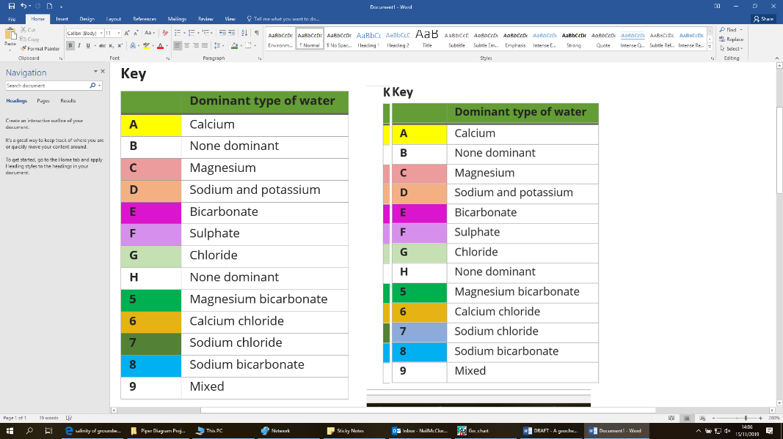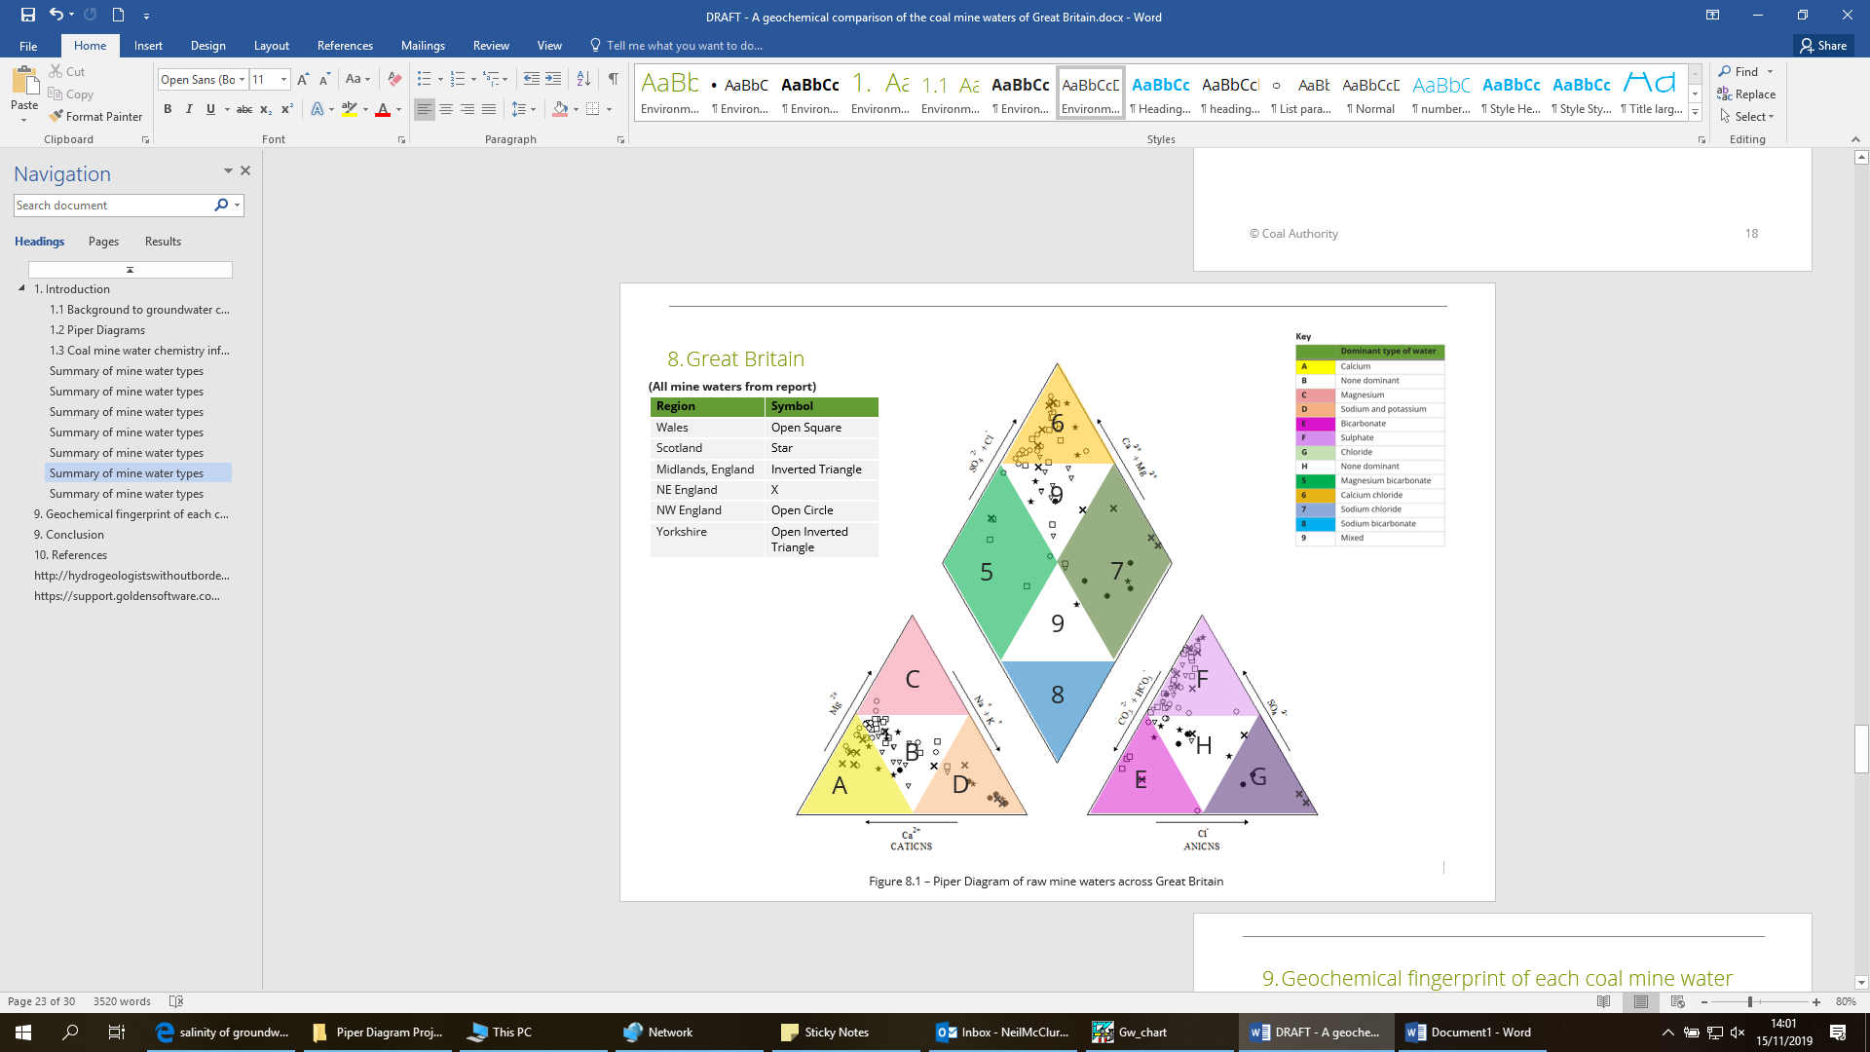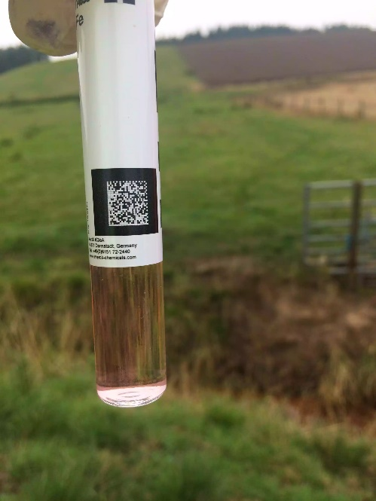

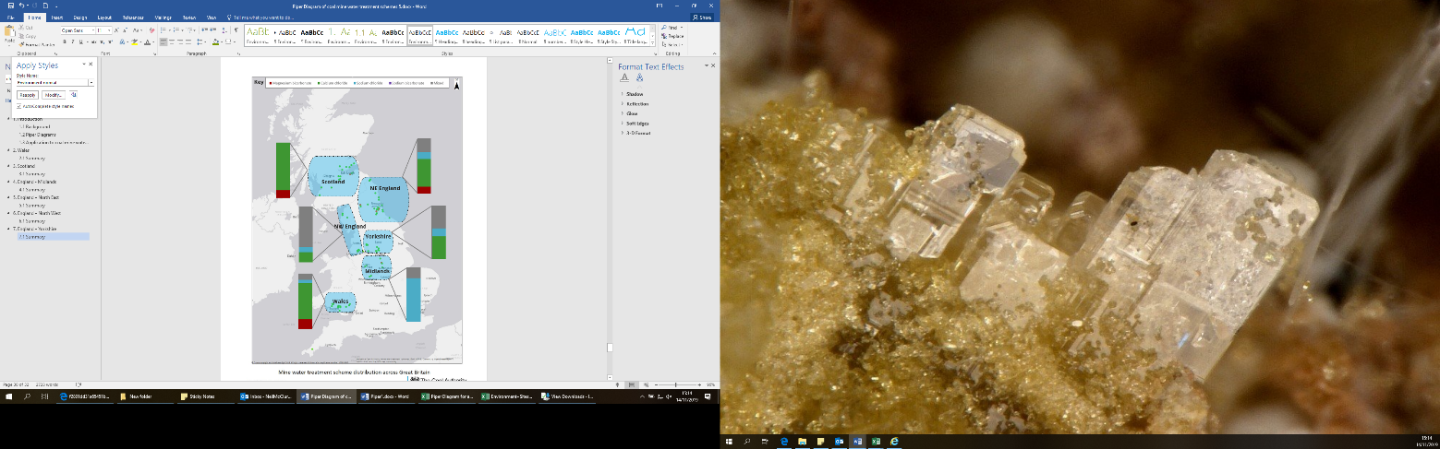

|  |  |  |  |  |
| --- | --- | --- | --- | --- |
| Version | Produced by | Reviewed by | Approved by | Date |
| Draft | Neil McClure |  |  |  |
| V1 |  |  |  |  |
| V2 |  |  |  |  |

The Coal Authority, 200 Lichfield Lane, Mansfield, Nottinghamshire, NG18 4RG

Contents

1. Introduction 1

1.1 Background to groundwater chemistry 1

1.2 Piper Diagrams 3

1.3 Coal mine water chemistry information 5

2. Wales 7

Summary of mine water types 8

3. Scotland 9

Summary of mine water types 10

4. England - Midlands 11

Summary of mine water types 12

5. England – North East 13

Summary of mine water types 14

6. England – North West 15

Summary of mine water types 16

7. England – Yorkshire 17

Summary of mine water types 18

8. Great Britain 19

Summary of mine water types 20

9. Geochemical fingerprint of each coal mine water type 21

9. Conclusion 26

10. References 27

Table of figures

Figure 1.1: The Chebotarev sequence

Figure 1.2: A Piper diagram example

Figure 1.3: Mine water treatment scheme distribution across Great Britain

Figure 2.1 – Piper Diagram of mine waters in Wales

Figure 3.1 – Piper Diagram of mine waters in Scotland

Figure 4.1 – Piper Diagram of mine waters in England - Midlands

Figure 5.1 – Piper Diagram of mine waters in England – North East

Figure 6.1 – Piper Diagram of mine waters in England – North West

Figure 7.1 – Piper Diagram of mine waters in England – Yorkshire

Figure 8.1 – Piper Diagram of mine waters across Great Britain

Figure 9.1 – Geochemical fingerprint (cations) of types of coal mine waters per region in Great Britain

Figure 9.2 – Geochemical fingerprint (anions) of types of coal mine waters per region in Great Britain

Figure 9.3 – Geochemical fingerprint (cations + anions) of types of coal mine waters per region in Great Britain

Table of tables

Table 2.1 – Mine water classifications based on mine water chemistry, Wales

Table 3.1 – Mine water classifications based on mine water chemistry, Scotland

Table 4.1 – Mine water classifications based on mine water chemistry, England - Midlands

Table 5.1 – Mine water classifications based on mine water chemistry, England – North East

Table 6.1 – Mine water classifications based on mine water chemistry, England – North West

Table 7.1 – Mine water classifications based on mine water chemistry, England – Yorkshire

Table 8.1 – Mine water classifications based on mine water chemistry, Great Britain

Appendices

Appendix A – Caveats and assumptions

Executive Summary

Mine water is present throughout Great Britain across various depths and influenced by a large range of geological conditions. The chemistry of the mine water, in terms of anion and cation proportions, therefore differs considerably. Chemistry data for 64 coal mine waters across Great Britain have been plotted onto Piper Diagrams and compared by region (Wales, Scotland, NE England, NW England, Yorkshire, and Midlands of England).

By undertaking this exercise, it was observed that most coal mine waters across Great Britain are dominant as the sulphate type (for anions), with no dominant type for cations. There are seven mine waters dominant as the bicarbonate type. The Midlands and the North East of England both contain two chloride-rich mine waters each (A Winning and Mid Cannock; and Dawdon and Horden, respectively).

1. Introduction
   1. Background to groundwater chemistry

The composition of groundwater alters geochemically as it moves through rock. In general, the longer groundwater remains in contact with the surrounding rocks the greater the amount of material it will take into solution.

Chebotarev (1955) pioneered the systematic study of the geochemistry of natural groundwaters, and noted that the anionic content of groundwater provided useful information about the chemical processes to which the moving groundwater is subject.

The Chebotarev sequence is an idealised sequence of chemical changes in groundwater. For large sedimentary basins, the Chebotarev sequence can be described in terms of three main zones. These zones correlate in a general way with depth, and are as follows:

**The upper zone**—characterised by active groundwater flushing through relatively well-leached rocks. Water in this zone has HCO3- as the dominant anion and is low in total dissolved solids.

**The intermediate zone**— characterised by less active groundwater circulation and higher total dissolved solids. Sulphate is normally the dominant anion in this zone.

**The lower zone**— characterised by sluggish groundwater flow (to be almost stagnant). Highly soluble minerals are commonly present in this zone because very little groundwater flushing has occurred. High Cl– concentration and high total dissolved solids are characteristic of this zone.

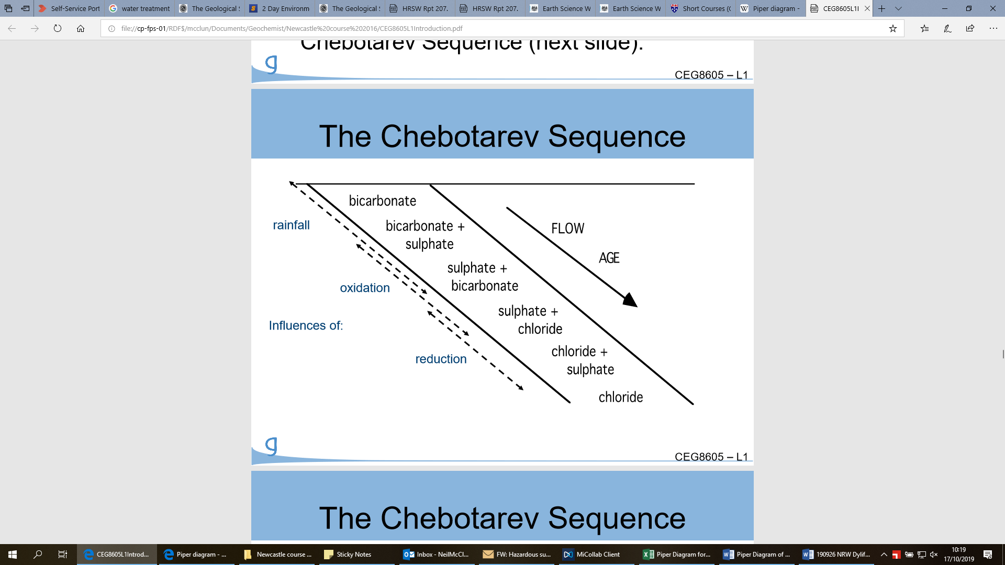

Figure 1.1: The Chebotarev sequence, an idealised sequence of chemical changes in groundwater. Changes in composition also occur with increasing depth of travel, as bicarbonate anions, which dominate in many shallow groundwaters, give way to sulphate and then chloride anions, and calcium is exchanged for sodium.

From a geochemical point of view, the anion-evolution sequence described above can be explained in terms of two main variables - mineral availability and mineral solubility (F&C, 1979).

The HCO3- content in groundwater is normally derived from both soil zone CO2 and the dissolution of the minerals calcite and dolomite. The partial pressures of CO2 generated in the soil zone and the solubility of calcite and dolomite limit the potential level of total dissolved solids attained. Rapid dissolution occurs when these minerals come in contact with CO2-charged groundwater, therefore HCO3- is almost invariably the dominant anion in areas of recharge.

With increased age and reduced flow, the groundwater becomes more influenced by the sulphate-bearing minerals gypsum, CaSO4 · 2H2O, and anhydrite, CaSO4. These minerals are more soluble than calcite and dolomite. Dissolution of gypsum causes the groundwater to become more brackish. A shift in composition phase in the Chebotarev evolution sequence becomes realised as the dominant anion shifts to SO42–.

Upon further aging and reduction in flow, the groundwater evolves past the stage where SO42– is the dominant anion to a Cl–-rich brine. This occurs when the groundwater comes into contact with highly soluble chloride minerals e.g. halite.

* 1. Piper Diagrams

Piper diagrams are graphical representations of the chemistry of a water sample (or samples). They aid in the understanding of the sources of dissolved constituents in water. Piper diagrams work on the assumption that the water sampled contains cations and anions in a chemical equilibrium.

The following ions are present in natural groundwaters in significant quantities:

**Cations** - Sodium, Potassium, Calcium, and Magnesium.

**Anions** - Bicarbonate, Sulphate, Chloride.

These cations and anions are plotted onto Piper Diagrams in the form of apexes (sodium and potassium cations are combined, and bicarbonate anions are combined with carbonate anions) on separate ternary plots.

The two ternary plots are then projected onto a diamond. The diamond is a matrix transformation of a graph of the anions (sulphate + chloride/total anions) and cations (sodium + potassium/total cations).

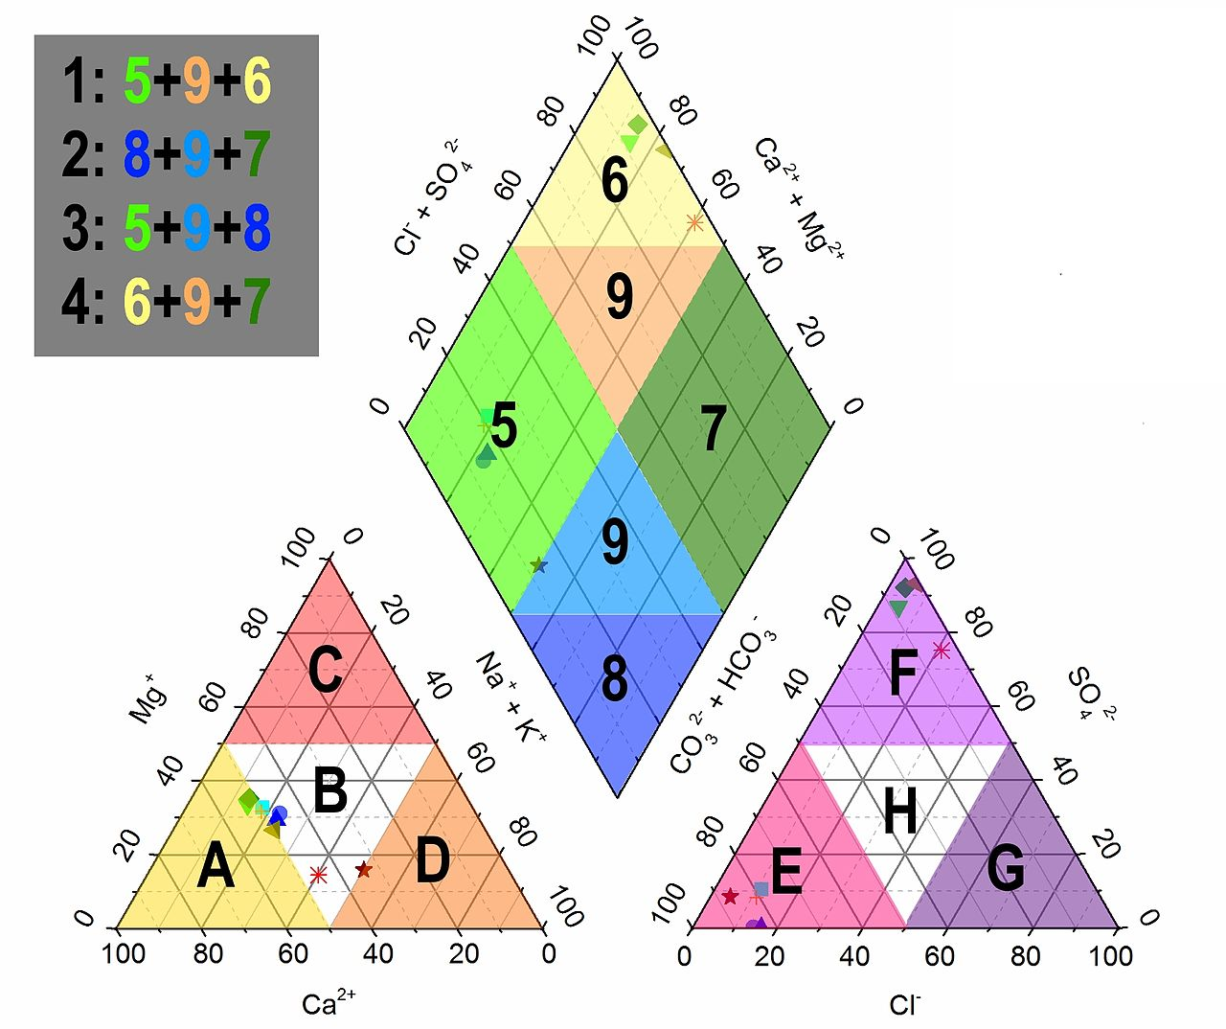Figure 1.2: A Piper diagram example, which can be separated into the following hydrochemical facies. Legend: **Cations**: A: Calcium type; B: No dominant type; C: Magnesium type; D: Sodium and potassium type; **Anions**: E: Bicarbonate type; F: Sulphate type; G: Chloride type; **Cations + Anions:** 5: Magnesium bicarbonate type; 6: Calcium chloride type; 7: Sodium chloride type; 8: Sodium bicarbonate type; 9: Mixed type

* 1. Coal mine water chemistry information

Mine water chemistry varies in its composition across Great Britain. In order to assess what the dominant types of the mine waters are (if any), a total of 64 different coal mine waters from across the country have been plotted on Piper Diagrams. These grouped into sections from the following regions:

* Wales
* Scotland
* England - Midlands
* England - North East
* England - North West
* Yorkshire

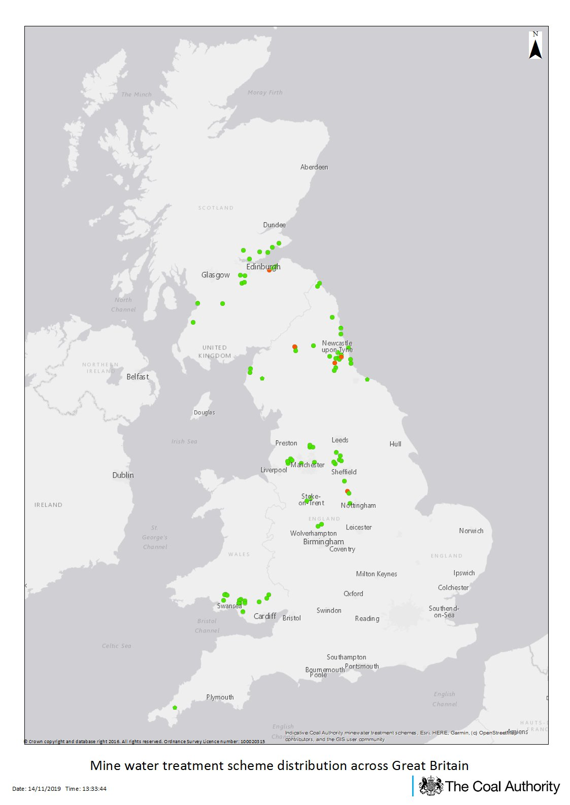

**Figure 1.3 –**

**NW England**

**Yorkshire**

**Wales**

**Midlands**

**NE England**

**Scotland**

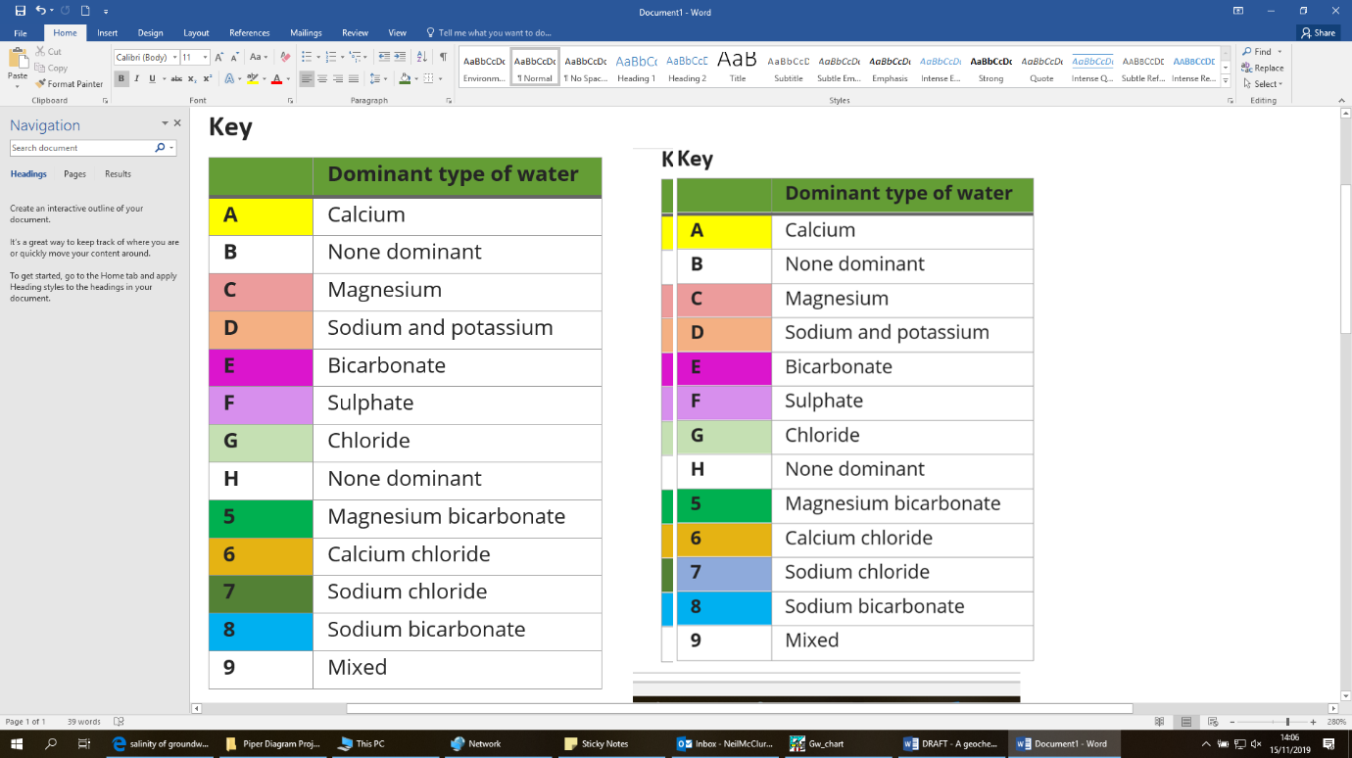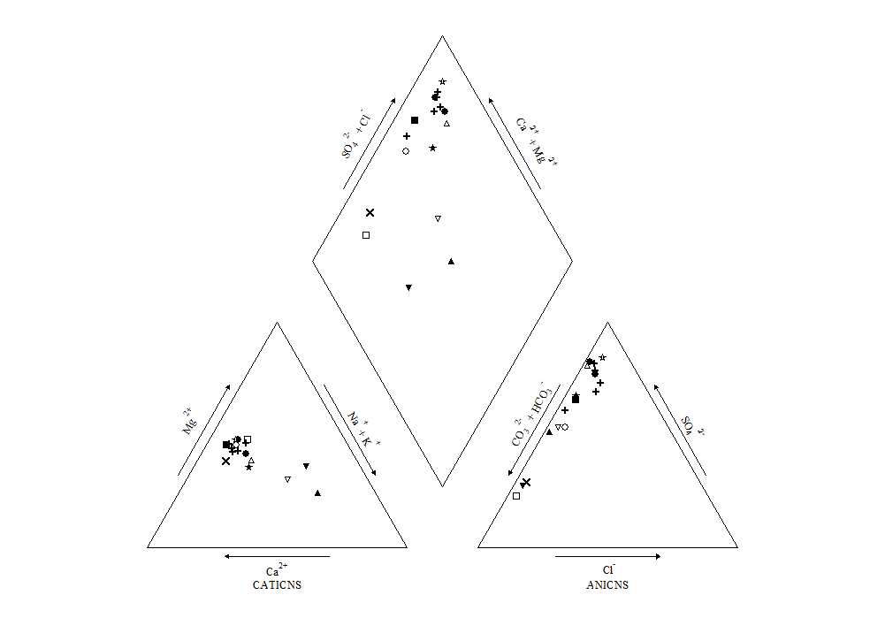

Figure 2.1 – Piper Diagram of raw mine waters in Wales

1. Wales

|  |  |
| --- | --- |
| Raw mine water | Symbol |
| Ynysarwed | Open triangle |
| Tan-y-Garn | Circle |
| Blaenavon | Cross |
| Gwynfi | Square |
| Lindsay | Inverted triangle |
| Six Bells | Triangle |
| Craig Yr Aber | Star |
| Taff Merthyr | X |

|  |  |
| --- | --- |
| Raw mine water | Symbol |
| Garth Tonmawr | Open star |
| Mountain Gate | Open square |
| Glyncastle | Circle |
| Morlais | Open inverted triangle |
| Corrwg | Open circle |
| Whitworth 1 | Cross |
| Gwenfrrwd | Cross |
| Whitworth A | Cross |
| Whitworth B | Cross |

8

9

9

6

H

G

F

E

B

C

7

5

D

A

Summary of mine water types

The composition of 17 raw mine waters throughout Wales has been assessed in this report, and ‘types’ designated based on their composition. The classifications are as follows:

|  |  |  |  |
| --- | --- | --- | --- |
| Cation/Anion | Legend | Type | Mine water in classification |
| Cation | A | Calcium | Taff Merthyr |
| B | None dominant | Ynysarwed, Tan-y-Garn, Blaenavon, Gwynfi, Lindsay, Craig Yr Aber, Garth Tonmawr, Mountain Gate, Glyncastle, Morlais, Corrwg, Whitworth 1 & A & B, Gwenfrrwd |
| C | Magnesium |  |
| D | Sodium and potassium | Six Bells |
| Anion | E | Bicarbonate | Mountain Gate, Taff Merthyr, Lindsay |
| F | Sulphate | Ynysarwed, Tan-y-Garn, Blaenavon, Gwynfi,, Craig Yr Aber, Garth Tonmawr, Glyncastle, Morlais, Corrwg, Whitworth 1 & A & B, Gwenfrrwd, Six Bells |
| G | Chloride |  |
| H | None dominant |  |
| Cation + Anion | 5 | Magnesium bicarbonate | Mountain Gate, Taff Merthyr, Lindsay |
| 6 | Calcium chloride | Ynysarwed, Tan-y-Garn, Blaenavon, Gwynfi,, Craig Yr Aber, Garth Tonmawr, Glyncastle, Whitworth 1 & A & B, Gwenfrrwd |
| 7 | Sodium chloride | Six Bells |
| 8 | Sodium bicarbonate |  |
| 9 | Mixed | Corrwg, Morlais |

Table 2.1 – mine water classifications based on mine water chemistry, Wales

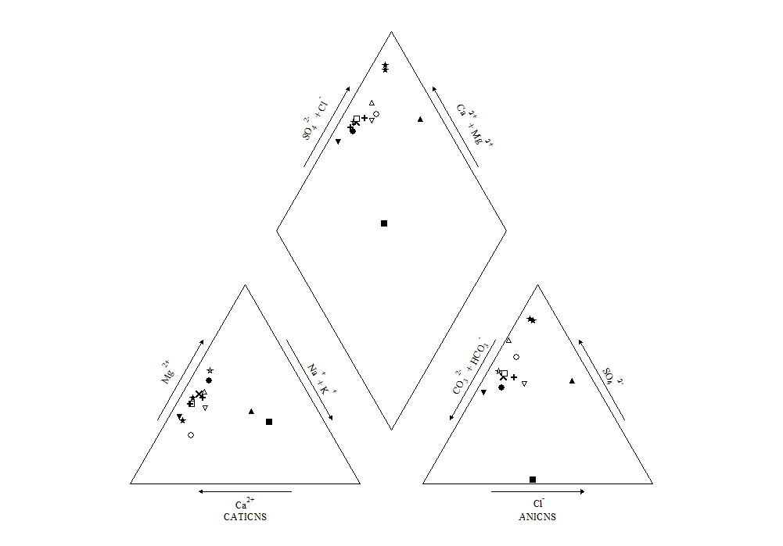

Figure 3.1 – Piper Diagram of raw mine waters in Scotland

|  |  |
| --- | --- |
| Raw mine water | Symbol |
| Lathallan Mill | Cross |
| Minto | Open Star |
| Monktonhall | Open Inverted Triangle |
| Mousewater | Open Square |
| Pitfirrane | Circle |
| Polkemmet | Open Triangle |
| Pool Farm | Cross |

1. Scotland

|  |  |
| --- | --- |
| Raw mine water | Symbol |
| Bilston Glen | Square |
| Blairingone | Star |
| Blindwells | X |
| Cuthill | Open Circle |
| Dalquarren | Star |
| Frances | Triangle |
| Kames | Inverted Triangle |

8

9

9

6

H

G

F

E

B

C

7

5

D

A

Summary of mine water types

The composition of 14 mine waters throughout Scotland has been assessed in this report, and ‘types’ designated based on their composition. The classifications are as follows:

|  |  |  |  |
| --- | --- | --- | --- |
| Cation/Anion | Legend | Type | Mine water in classification |
| Cation | A | Calcium | Blairingone , Cuthill, Dalquarren, Kames, Lathallan Mill, Mousewater, Pool Farm |
| B | None dominant | Bilston Glen, Blindwells, Frances, Monktonhall, Polkemmet |
| C | Magnesium | Minto, Pitfirrane |
| D | Sodium and potassium |  |
| Anion | E | Bicarbonate | Bilston Glen, Kames |
| F | Sulphate | Blairingone, Blindwells, Cuthill, Dalquarren, Frances, Lathallan Mill, Minto, Monktonhall, Mousewater, Polkemmet, Pool Farm |
| G | Chloride |  |
| H | None dominant | Pitfirrane |
| Cation + Anion | 5 | Magnesium bicarbonate | Bilston Glen, Kames |
| 6 | Calcium chloride | Blairingone, Blindwells, Cuthill, Dalquarren, Frances, Lathallan Mill, Minto, Monktonhall, Mousewater, Pitfirrane, Polkemmet, Pool Farm |
| 7 | Sodium chloride |  |
| 8 | Sodium bicarbonate |  |
| 9 | Mixed |  |

Table 3.1 – mine water classifications based on mine water chemistry, Scotland

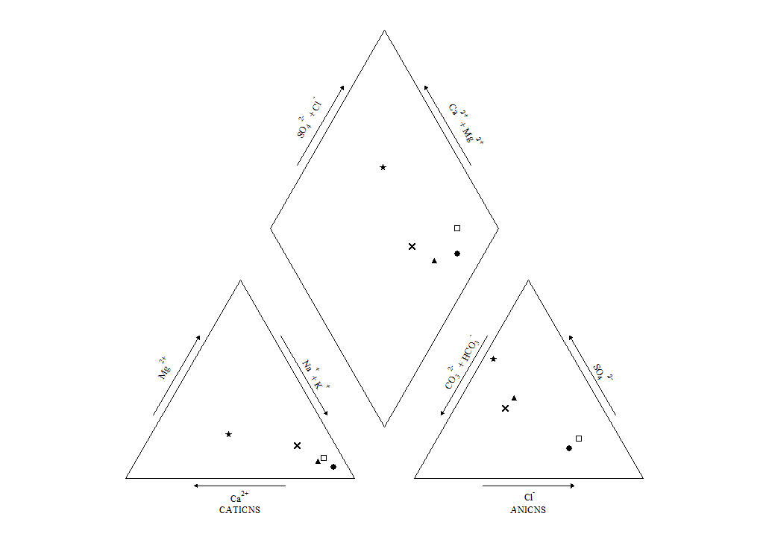

Figure 4.1 – Piper Diagram of raw mine waters in Midlands, England

1. England - Midlands

|  |  |
| --- | --- |
| Raw mine water | Symbol |
| A Winning | Open Square |
| Mid Cannock | Circle |
| Cannock Wood | Triangle |
| Silverdale | Star |
| Woodside | X |

8

9

9

6

H

G

F

E

B

C

7

5

D

A

Summary of mine water types

The composition of 5 raw mine waters throughout the Midlands in England has been assessed in this report, and ‘types’ designated based on their composition. The classifications are as follows:

|  |  |  |  |
| --- | --- | --- | --- |
| Cation/Anion | Legend | Type | Mine water in classification |
| Cation | A | Calcium |  |
| B | None dominant | Silverdale |
| C | Magnesium | A Winning, Mid Cannock, Cannock Wood, Woodside |
| D | Sodium and potassium |  |
| Anion | E | Bicarbonate |  |
| F | Sulphate | Silverdale |
| G | Chloride | A Winning, Mid Cannock |
| H | None dominant | Cannock Wood, Woodside |
| Cation + Anion | 5 | Magnesium bicarbonate |  |
| 6 | Calcium chloride |  |
| 7 | Sodium chloride | A Winning, Mid Cannock, Cannock Wood, Woodside |
| 8 | Sodium bicarbonate |  |
| 9 | Mixed | Silverdale |

Table 4.1 – mine water classifications based on mine water chemistry, Midlands, England

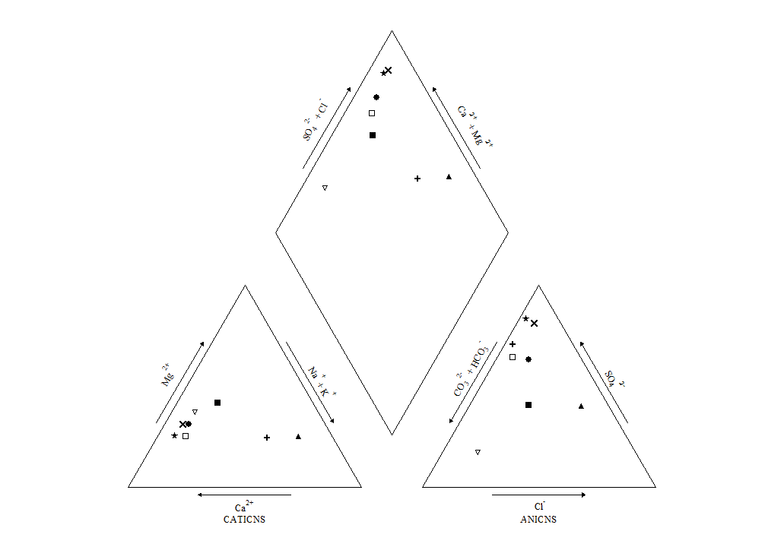

1. England – North East

|  |  |
| --- | --- |
| Raw mine water | Symbol |
| Acomb | Open Square |
| Allerdean Mill | Circle |
| Bates | Triangle |
| Blenkinsopp | Star |
| Edmondsley | X |
| Lambley | Open Inverted Triangle |
| Stoney Heap | Square |
| Whittle | Cross |
| Horden | Open circle |
| Dawdon | Open circle |

Figure 5.1 – Piper Diagram of raw mine waters in North East of England

E

8

9

9

6

H

G

F

B

C

7

5

D

A

Summary of mine water types

The composition of 8 raw mine waters throughout the North East of England has been assessed in this report, and ‘types’ designated based on their composition. The classifications are as follows:

|  |  |  |  |
| --- | --- | --- | --- |
| Cation/Anion | Legend | Type | Mine water in classification |
| Cation | A | Calcium | Acomb, Allerdean Mill, Blenkinsopp, Edmondsley, Stoney Heap |
| B | None dominant | Lambley, Whittle |
| C | Magnesium |  |
| D | Sodium and potassium | Bates |
| Anion | E | Bicarbonate | Lambley |
| F | Sulphate | Acomb, Allerdean Mill, Blenkinsopp, Edmondsley, Whittle |
| G | Chloride |  |
| H | None dominant | Bates, Stoney Heap |
| Cation + Anion | 5 | Magnesium bicarbonate | Lambley |
| 6 | Calcium chloride | Acomb, Allerdean Mill, Blenkinsopp, Edmondsley |
| 7 | Sodium chloride | Bates |
| 8 | Sodium bicarbonate |  |
| 9 | Mixed | Whittle, Stoney Heap |

Table 5.1 – mine water classifications based on mine water chemistry, NE England

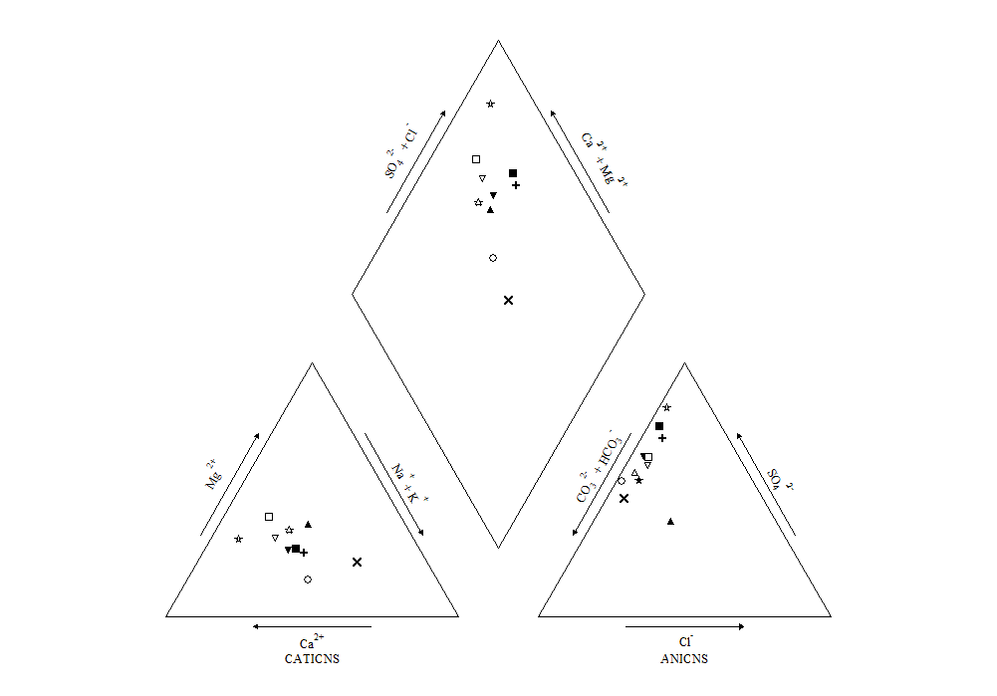

1. England – North West

|  |  |
| --- | --- |
| Raw mine water | Symbol |
| Aspull Sough | Square |
| Bridgewater Canal | Star |
| Downbrook | Open Triangle |
| Deerplay | Open Circle |
| Ewanrigg | Open Inverted Triangle |
| Fennyfield | Triangle |
| Great Clifton | Inverted Triangle |
| Hockery Brook | Cross |
| Old Meadows | Open Star |
| Pemberton | X |
| Summersales | Open Square |

Figure 6.1 – Piper Diagram of raw mine waters in North West of England

8

9

9

6

H

G

F

E

B

C

7

5

D

A

Summary of mine water types

The composition of 11 raw mine waters throughout the North West of England has been assessed in this report, and ‘types’ designated based on their composition. The classifications are as follows:

|  |  |  |  |
| --- | --- | --- | --- |
| Cation/Anion | Legend | Type | Mine water in classification |
| Cation | A | Calcium | Old Meadows |
| B | None dominant | Aspull Sough, Bridgewater Canal, Downbrook, Deerplay, Ewanrigg, Fennyfield, Great Clifton, Hockery Brook, Summersales |
| C | Magnesium |  |
| D | Sodium and potassium | Pemberton |
| Anion | E | Bicarbonate |  |
| F | Sulphate | Aspull Sough, Bridgewater Canal, Downbrook, Deerplay, Ewanrigg, Great Clifton, Hockery Brook, Old Meadows, Summersales |
| G | Chloride |  |
| H | None dominant | Fennyfield, Pemberton |
| Cation + Anion | 5 | Magnesium bicarbonate |  |
| 6 | Calcium chloride | Old Meadows, Summersales |
| 7 | Sodium chloride | Pemberton |
| 8 | Sodium bicarbonate |  |
| 9 | Mixed | Aspull Sough, Bridgewater Canal, Downbrook, Deerplay, Ewanrigg, Great Clifton, Hockery Brook |

Table 6.1 – mine water classifications based on mine water chemistry in NW England

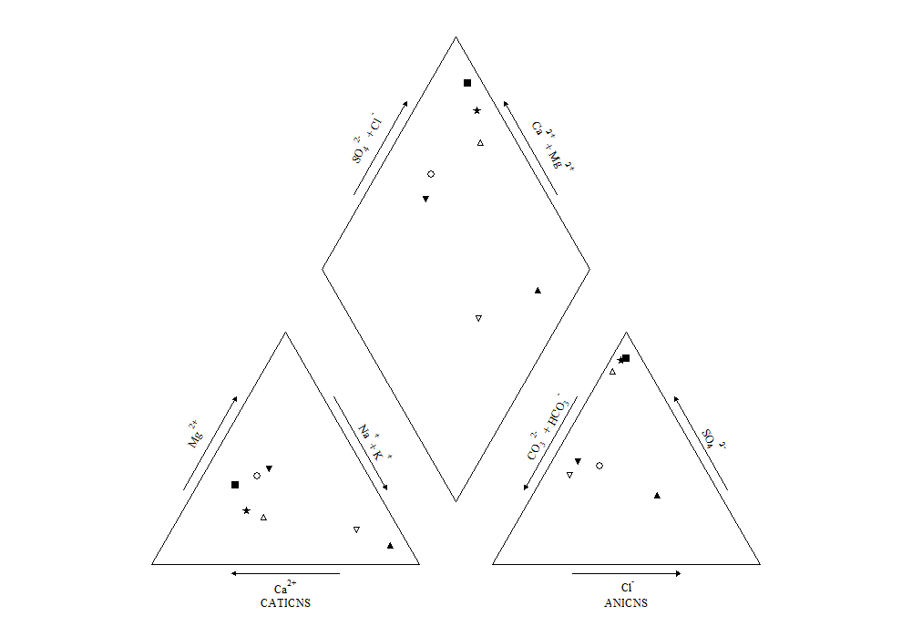

Figure 7.1 – Piper Diagram of raw mine waters in Yorkshire, England

D

1. England – Yorkshire

|  |  |
| --- | --- |
| Raw mine water | Symbol |
| Bullhouse | Square |
| Clough Foot | Star |
| Fender | Inverted Triangle |
| Sheephouse Wood | Open Triangle |
| Silkstone | Open Circle |
| Strafford | Open Inverted Triangle |
| Woolley | Triangle |

8

9

9

6

H

G

F

E

B

C

7

5

A

Summary of mine water types

The composition of 7 raw mine waters throughout Yorkshire, England has been assessed in this report, and ‘types’ designated based on their composition. The classifications are as follows:

|  |  |  |  |
| --- | --- | --- | --- |
| Cation/Anion | Legend | Type | Mine water in classification |
| Cation | A | Calcium | Bullhouse, Clough Foot |
| B | None dominant | Fender, Sheephouse Wood, Silkstone |
| C | Magnesium | Strafford, Woolley |
| D | Sodium and potassium |  |
| Anion | E | Bicarbonate | Strafford |
| F | Sulphate | Bullhouse Clough Foot, Sheephouse Wood |
| G | Chloride |  |
| H | None dominant | Fender, Silkstone, Woolley |
| Cation + Anion | 5 | Magnesium bicarbonate |  |
| 6 | Calcium chloride | Bullhouse, Clough Foot, Sheephouse Wood |
| 7 | Sodium chloride | Woolley |
| 8 | Sodium bicarbonate |  |
| 9 | Mixed | Fender, Silkstone, Strafford |

Table 7.1 – mine water classifications based on mine water chemistry in Yorkshire, England

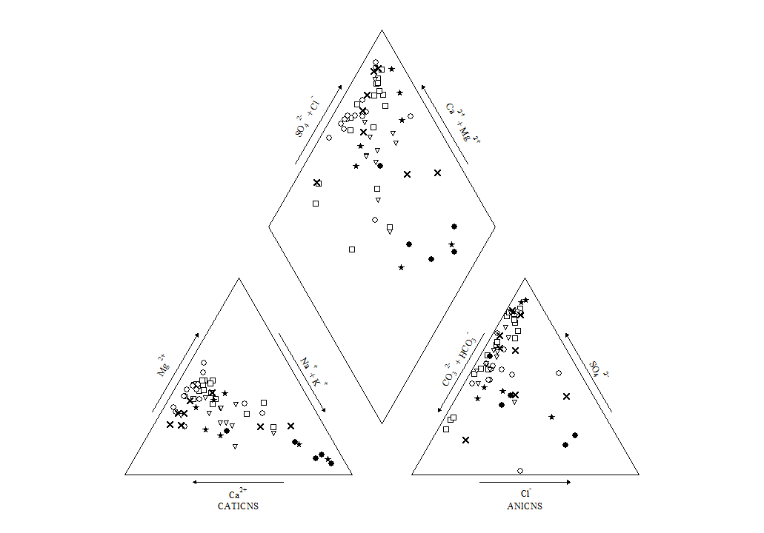

1. Great Britain

**(All mine waters from report)**

|  |  |
| --- | --- |
| Region | Symbol |
| Wales | Open Square |
| Scotland | Star |
| Midlands, England | Inverted Triangle |
| NE England | X |
| NW England | Open Circle |
| Yorkshire | Open Inverted Triangle |

Figure 8.1 – Piper Diagram of raw mine waters across Great Britain

D

8

9

9

6

H

G

F

E

B

C

7

5

A

Summary of mine water types

|  |  |  |  |  |
| --- | --- | --- | --- | --- |
| Cation/Anion |  | Type | Mine water in classification | Total of  type |
| Cation | A | Calcium | **Wales** – Taff Merthyr. **Scotland**– Blairingone, Cuthill, Dalquarren, Kames, Lathallan Mill, Mousewater, Pool Farm. **Midlands England**– N/A. **NE England**– Acomb, Allerdean Mill, Blenkinsopp, Edmondsley, Stoney Heap. **NW England**– Old Meadows. **Yorkshire**– Bullhouse, Clough Foot | 16 |
| B | None dominant | **Wales** –Ynysarwed, Tan-y-Garn, Blaenavon, Gwynfi, Lindsay, Craig Yr Aber, Garth Tonmawr, Mountain Gate, Glyncastle, Morlais, Corrwg, Whitworth 1 & A & B, Gwenfrrwd.  **Scotland**– Bilston Glen, Blindwells, Frances, Monktonhall, Polkemmet. **Midlands England**– Silverdale. **NE England**– Lambley, Whittle. **NW England**– Aspull Sough, Bridgewater Canal, Downbrook, Deerplay, Ewanrigg, Fennyfield, Great Clifton, Hockery Brook, Summersales. **Yorkshire**– Fender, Sheephouse Wood, Silkstone | 35 |
| C | Magnesium | **Wales** – N/A. **Scotland**– Minto, Pitfirrane. **Midlands England**– A Winning, Mid Cannock, Cannock Wood, Woodside. **NE England**– N/A. **NW England**– N/A. **Yorkshire**– Strafford, Woolley | 8 |
| D | Sodium and potassium | **Wales** – Six Bells. **Scotland**– N/A. **Midlands England**– N/A.  **NE England**– Dawdon, Horden, Bates. **NW England**– Pemberton. **Yorkshire**– N/A | 3 |
| Anion | E | Bicarbonate | **Wales** – Mountain Gate, Taff Merthyr, Lindsay. **Scotland**– Bilston Glen, Kames. **Midlands England**– N/A.  **NE England**– Lambley. **NW England**– N/A. **Yorkshire**– Strafford. | 7 |
| F | Sulphate | **Wales** - Ynysarwed, Tan-y-Garn, Blaenavon, Gwynfi, Craig Yr Aber, Garth Tonmawr, Glyncastle, Morlais, Corrwg, Whitworth 1 & A & B, Gwenfrrwd, Six Bells. **Scotland**– Blairingone, Blindwells, Cuthill, Dalquarren, Frances, Lathallan Mill, Minto, Monktonhall, Mousewater, Polkemmet, Pool Farm.  **Midlands England**– Silverdale.  **NE England**– Acomb, Allerdean Mill, Blenkinsopp, Edmondsley, Whittle. **NW England**– Aspull Sough, Bridgewater Canal, Downbrook, Deerplay, Ewanrigg, Great Clifton, Hockery Brook, Old Meadows, Summersales. **Yorkshire**– Bullhouse Clough Foot, Sheephouse Wood | 43 |
| G | Chloride | **Wales** – N/A. **Scotland**– N/A. **Midlands England**– A Winning, Mid Cannock. **NE England**– Dawdon, Horden. **NW England**– N/A. **Yorkshire**– N/A | 2 |
| H | None dominant | **Wales** – N/A. **Scotland**– Pitfirrane. **Midlands England**– Cannock Wood, Woodside. **NE England**– Bates, Stoney Heap. **NW England**– Fennyfield, Pemberton. **Yorkshire**– Fender, Silkstone, Woolley | 10 |
| Cation + Anion | 5 | Magnesium bicarbonate | **Wales** - Mountain Gate, Taff Merthyr, Lindsay. **Scotland** - Bilston Glen, Kames.  **Midlands England**– N/A. **NE England**– Lambley. **NW England**– N/A. **Yorkshire**– N/A | 6 |
| 6 | Calcium chloride | **Wales** – Ynysarwed, Tan-y-Garn, Blaenavon, Gwynfi, Craig Yr Aber, Garth Tonmawr, Glyncastle, Whitworth 1 & A & B, Gwenfrrwd.  **Scotland**– Blairingone, Blindwells, Cuthill, Dalquarren, Frances, Lathallan Mill, Minto, Monktonhall, Mousewater, Pitfirrane, Polkemmet, Pool Farm.  **Midlands England**– N/A. **NE England**– Acomb, Allerdean Mill, Blenkinsopp, Edmondsley. **NW England**– Old Meadows, Summersales.  **Yorkshire**– Bullhouse, Clough Foot, Sheephouse Wood | 32 |
| 7 | Sodium chloride | **Wales** – Six Bells. **Scotland**– N/A. **Midlands England**– A Winning, Mid Cannock, Cannock Wood, Woodside. **NE England**– Dawdon, Horden, Bates. **NW England**–Pemberton. **Yorkshire**– Woolley | 8 |
| 8 | Sodium bicarbonate | **Wales** – N/A. **Scotland**– N/A. **Midlands England**– N/A. **NE England**– N/A. **NW England**– N/A. **Yorkshire** - N/A. | 0 |
| 9 | Mixed | **Wales** – Corrwg, Morlais. **Scotland**– N/A. **Midlands England**– Silverdale. **NE England**– Whittle, Stoney Heap. **NW England**– Aspull Sough, Bridgewater Canal, Downbrook, Deerplay, Ewanrigg, Great Clifton, Hockery Brook. **Yorkshire**– Fender, Silkstone, Strafford | 16 |

**Table 8.1- Summary of types of coal mine waters in Great Britain**

1. Geochemical fingerprint of each coal mine water type

In order to obtain a high level “geochemical fingerprint” of the dominant mine water types across Great Britain:

* All coal mine water types were added together across each region, then each type was calculated as a percentage breakdown of each region (e.g. 15/17 cations in Wales of the non-dominant type = 88%).
* The percentage breakdowns per regions of cations types, anions types and both types combined were placed in the form of a bar chart on the following maps to display a “geochemical fingerprint” of each region.

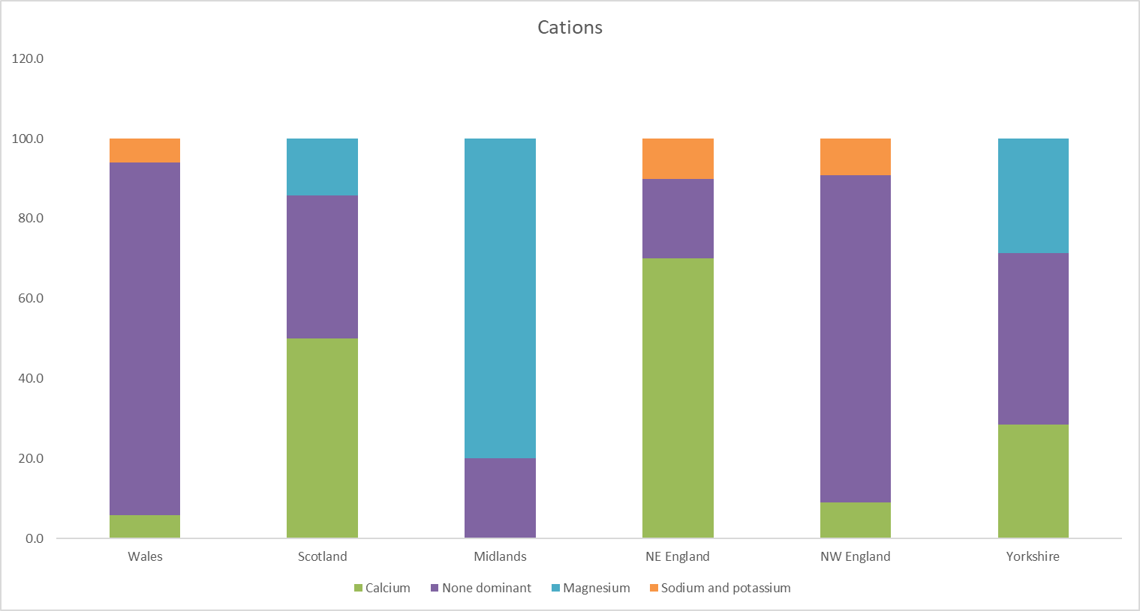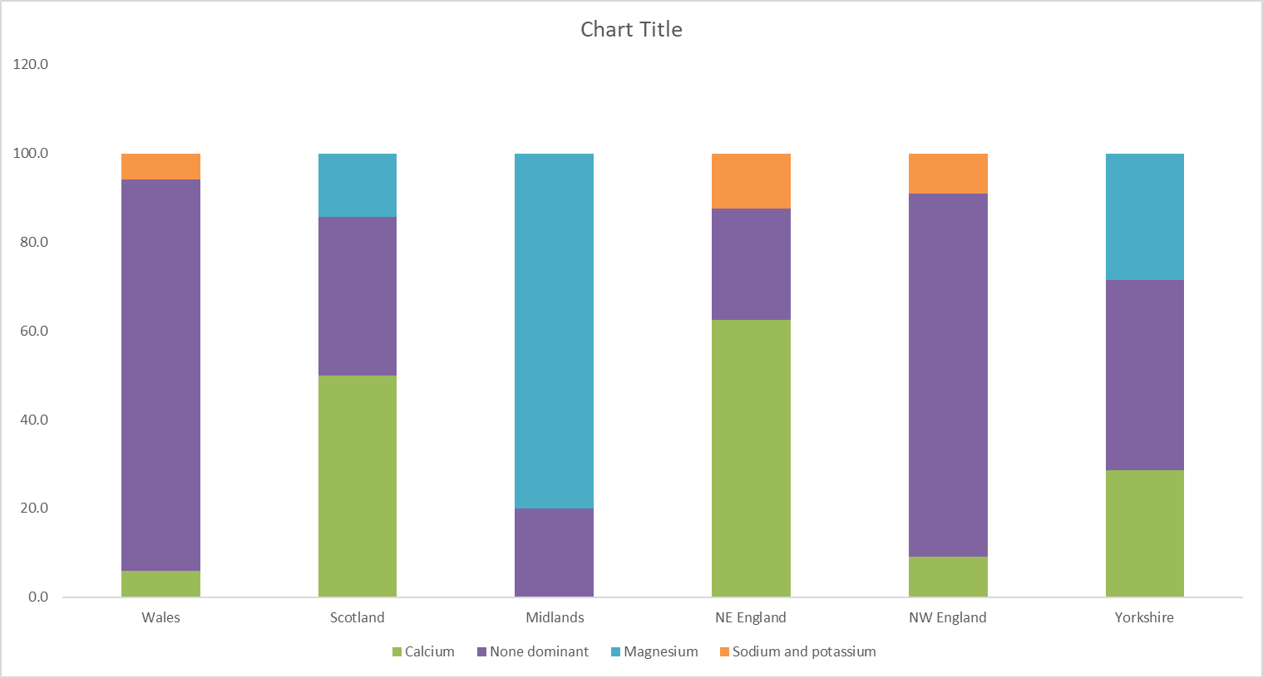

Figure 9.1 – Geochemical fingerprint (cations) of types of coal mine waters per region in Great Britain

**Key**

**Wales**

**NW England**

**Yorkshire**

**Midlands**

**NE England**

**Scotland**

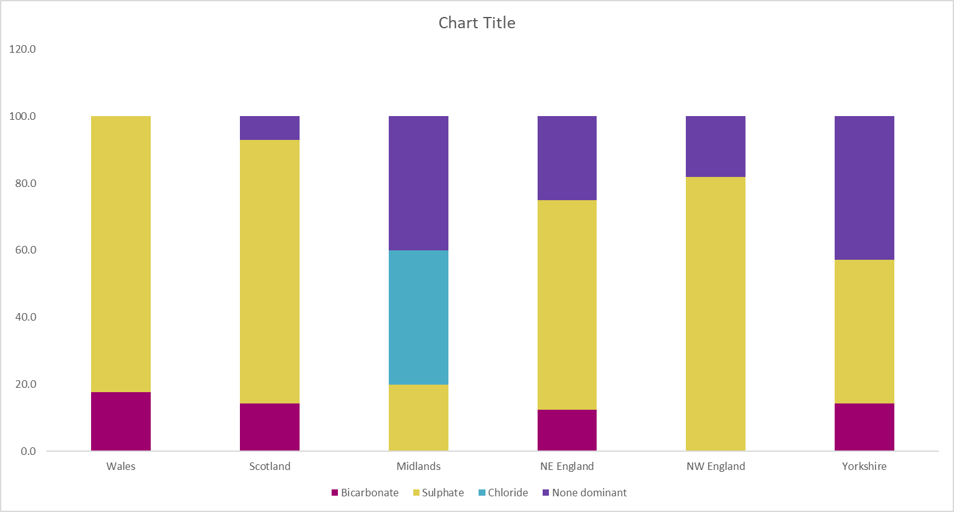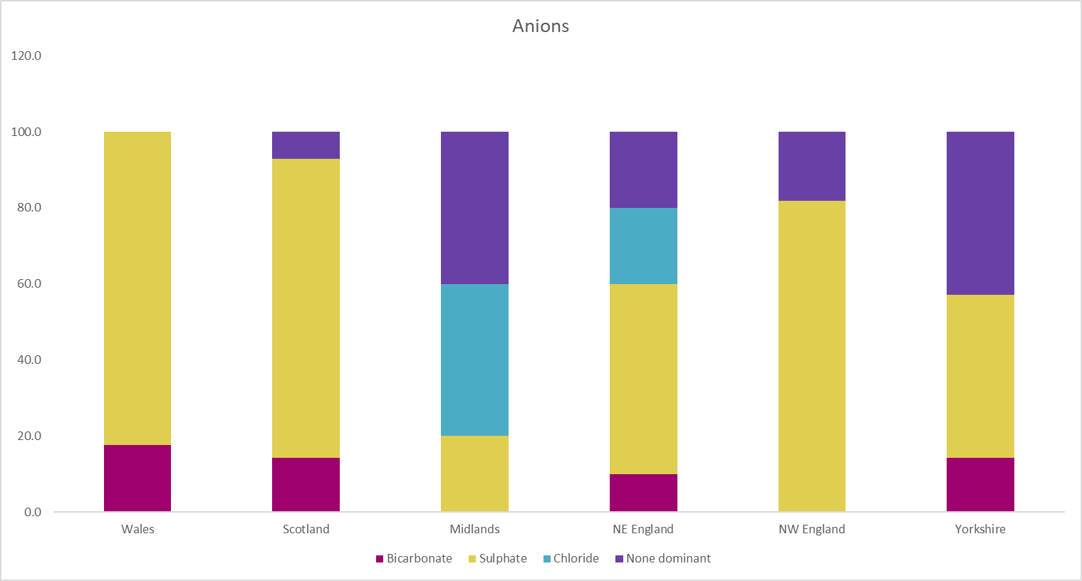

Figure 9.2 – Geochemical fingerprint (anions) of types of coal mine waters per region in Great Britain

**Key**

**Wales**

**NW England**

**Yorkshire**

**Midlands**

**NE England**

**Scotland**

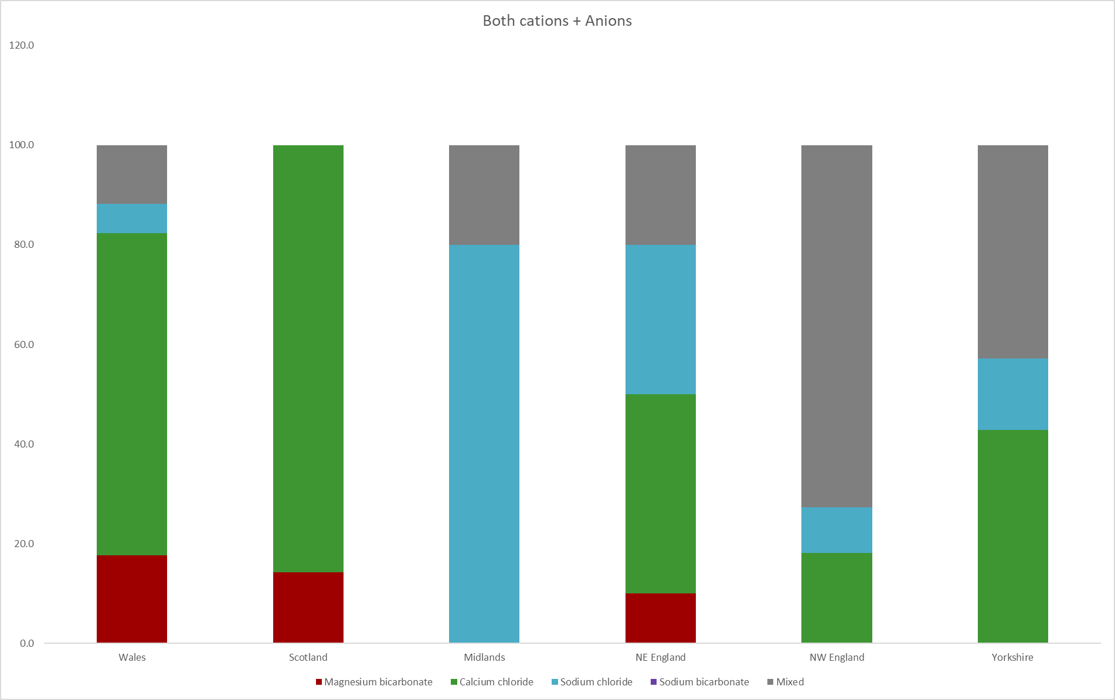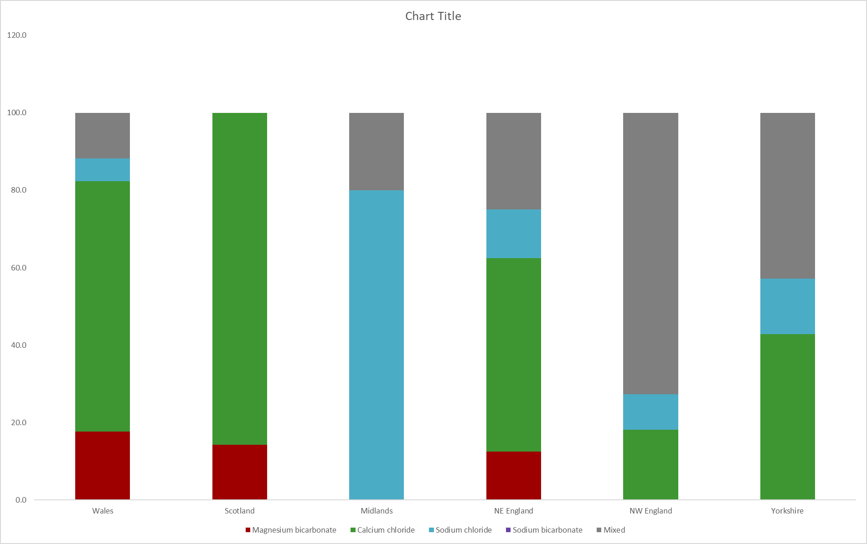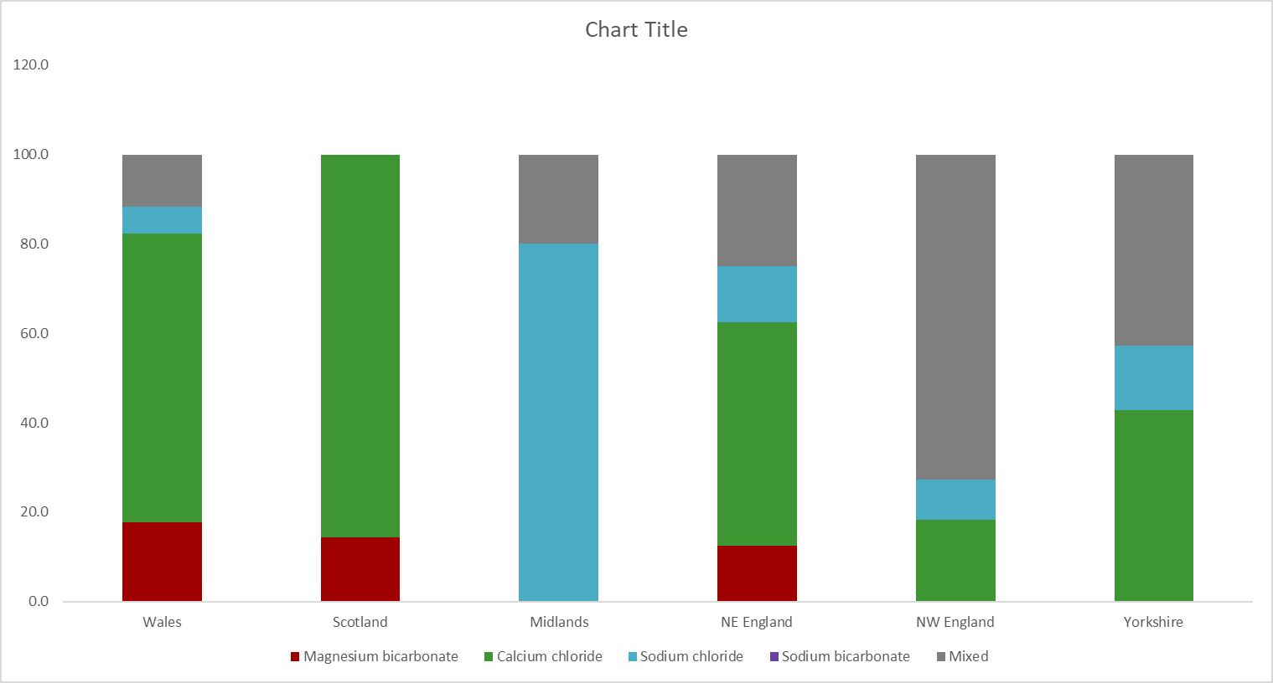

Figure 9.3 – Geochemical fingerprint (cations + anions) of types of coal mine waters per region in Great Britain

**Key**

**Wales**

**NW England**

**Yorkshire**

**Midlands**

**NE England**

**Scotland**

**Geochemical fingerprint assessment**

**Cations**

* Wales and NW England mine waters have a similar cation geochemical fingerprint. Most mine waters do not have a dominant cation type. There is one calcium dominated mine water in Wales and NW England (Taff Merthyr and Old Meadows, respectively), as well as a sodium and potassium dominated mine water (Six Bells and Pemberton, respectively).
* Scotland and Yorkshire mine waters generally have a similar cation geochemical fingerprint, with the calcium type, magnesium type and no dominant type present in slightly different proportions. The majority of mine waters assessed in Scotland are calcium dominated.
* The NE England mine waters are generally calcium dominated for the most part, with a smaller proportion of mine waters with no dominance and sodium and potassium dominance.
* The Midlands in England contain mostly magnesium dominated mine waters, with one mine water (Silverdale) not having a dominant cation type.

**Anions**

* Wales, NW England and Scotland mine waters are all strongly sulphate dominated.
  + Wales contains three bicarbonate dominated mine waters (Mountain Gate, Taff Merthyr, Lindsay) out of the seventeen assessed.
  + NW England contains two mine waters with no anion dominance (Fennyfield, Pemberton) out of the eleven assessed.
  + Scotland contains two mine waters (Bilston Glen, Kames) which are bicarbonate dominant, and one mine water which has no dominance (Pitfirraine).
  + The remainder of mine waters in these regions are sulphate dominated.
* The majority of mine waters in NE England are sulphate dominated. NE England is the only region that contains mine waters dominant in bicarbonate, sulphate, and chloride anions. There are also several mine waters with no particular dominance. This region is therefore reflective of mine waters across a wide range in age and flow conditions.
* Yorkshire mine waters have an equal split between sulphate dominance and no dominance. One mine water is bicarbonate dominated (Strafford).
* The Midlands mine waters have an equal split between chloride dominance and no dominance. One mine water is sulphate dominated (Silverdale).

**Cations + Anions**

* Wales contains mine waters strongly of the calcium chloride type, and several mine waters of the magnesium bicarbonate type, mixed composition type, and one of the sodium chloride type (Six Bells).
* NW England contains mine waters for the most part of a mixed composition type, two of the calcium chloride type (Old Meadows, Summersales) and one of the sodium chloride type (Pemberton).
* Scotland mine waters are strongly of the calcium chloride type, with two mine waters (Bilston Glen and Kames) designated under the magnesium bicarbonate type.
* NE England mine waters are a mixture of types (magnesium bicarbonate, calcium chloride, sodium chloride and mixed composition).
* Yorkshire mine waters are mostly of the calcium chloride type and mixed composition type, with one mine water of the sodium chloride type (Woolley).
* Midlands mine waters are almost exclusively of the sodium chloride type, with the exception of one mine water (Silverdale) designated under the mixed composition type.
* There are similarities in both the presence (calcium chloride, sodium chloride and mixed composition) and proportion of cations and anions in mine waters from NW England and Yorkshire.
* There are similarities in both the presence (magnesium bicarbonate, calcium chloride, sodium chloride and mixed composition) and proportion of cations and anions in mine waters from Wales and NE England.
* There are no sodium bicarbonate dominated mine waters present in this study.

1. Conclusion

* A total of 64 mine waters in Great Britain have been investigated for assessment of their “types” – in terms of dominant cations, anions and a combination of both.
* The majority of coal mine waters in Great Britain have no dominant cation type (35 in total), and have a dominant sulphate type (43 in total).
* The majority of mine waters are of the calcium chloride type (32 in total).
* Three mine waters in Wales and two mine waters in Scotland are of the bicarbonate type. There are only seven of the bicarbonate type in this analysis – suggesting that mine waters in England are generally at a greater depth due to their relative progression along the Chebotarev sequence in terms of anion composition.
* There are only four mine waters in total which have a dominant chloride type (A Winning, Mid Cannock, Dawdon and Horden). These are deep mine waters which have interacted with the surrounding geology over a relatively long period of time compared with other mine waters in this study.
* Mine waters of the Midlands in England appear to be most different from the composition of mine waters across the rest of Great Britain, with the majority being of the sodium chloride type. However, this sample set was lower than other regions studied (n=5), therefore more data must be assessed to see if the geochemical fingerprint determined in this report is truly reflective of this region as a whole.

1. References

**Journal**

**Chebotarev**, I.I, 1955. Metamorphism of natural waters in the crust of weathering.

**Websites  
Chemical Evolution of Natural Groundwater,** F&C 1979, Last accessed 14th November 2019.

<http://hydrogeologistswithoutborders.org/wordpress/1979-english/chapter-7/>

**What is a Piper Diagram?,** Golden Software, Last accessed 14th November 2019.

<https://support.goldensoftware.com/hc/en-us/articles/115003101648-What-is-a-piper-plot-trilinear-diagram->

**How to Convert Tds to Conductivity** Sciencing.com, Last accessed 14th November 2019.

<https://sciencing.com/convert-tds-conductivity-7381015.html>

**Software**

Piper Diagrams created using GW_Chart software.

Appendix A – Caveats and assumptions

* The mine water chemistries have all been based on mean values of the relevant analytes, spanning from March 2015 until May 2017.
* Electrical conductivity results were available, however not Total Dissolved Solids (TDS). TDS was estimated by multiplying electrical conductivity (μS/cm @ 25oC) mesaurements by a factor of 0.67 as an approximate conversion factor.
* Total alkalinity (as CaCO3) results were available, however not bicarbonate results. Estimated bicarbonate concentration was assumed to be total alkalinity as CaCO3, and estimated carbonate concentration was assumed to be zero (due to the presence of mostly circum-neutral pH mine waters across Great Britain correlating with negligible carbonate concentrations).